# **CABLESETC 30cm DisplayPort DP 1.2 Male to Female Audio Video Adapter Extension Cable with Screw Hole Panel Mount**

<https://www.amazon.in/CABLESETC-DisplayPort-Female-Adapter-Extension/dp/B08GCFJNS9/ref=asc_df_B08GCFJNS9/?tag=googleshopdes-21&linkCode=df0&hvadid=397009549354&hvpos=&hvnetw=g&hvrand=3239140601260409709&hvpone=&hvptwo=&hvqmt=&hvdev=c&hvdvcmdl=&hvlocint=&hvlocphy=9062037&hvtargid=pla-1554691671352&psc=1&ext_vrnc=hi#descriptionAndDetails>

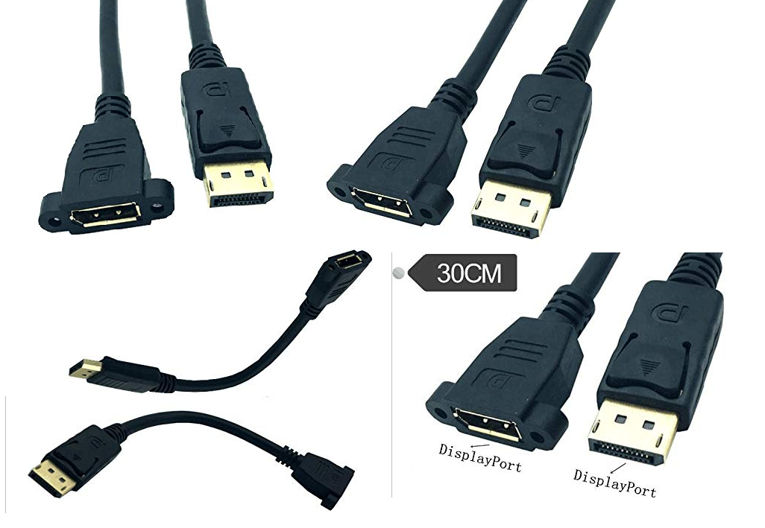

**Product description**

***CABLESETC's DisplayPort Panel-Mount extension cables****are the perfect solution for next-generation high-resolution video and audio. Now you can directly access HDTV equipment through walls or cabinets, with no on-site termination or hassle.*

Get your installations done right with our convenient DisplayPort digital video panel-mount cables. Installation with mounting cables instead of couplers means the fewest connections possible, maintaining perfect signal clarity and reducing noise-vulnerable gaps.

**About this cable:** With a panelmount DisplayPort cable, you can provide remote access to a video source or display directly on a wall plate, front panel, custom enclosure, or any cuttable or punchable mounting surface. Home theaters, editing studios, computer labs, and retail displays all benefit from the cleanliness and hot-swapability of mounted DisplayPort jacks.

**About DisplayPort:** DisplayPort is one of the new generations of video formats, very similar to (and in competition with) HDMI. While HDMI is targeted primarily towards home theater electronics, DisplayPort is finding more popularity with computer-centric electronics. DisplayPort is capable of carrying several times the data of a DVI cable in a smaller form factor, and also carries high-fidelity digital audio.

**Features:**

* CL2 rated for in-wall use
* Gold-plated contacts
* Shielded against RFI and EMI interference

**Specifications:**

* 1x Female DisplayPort Connector
* 1x Locking Male DisplayPort Connector
* Supports resolutions up to 4K UHD @ 60Hz
* Wire Gauge 26 AWG
* RoHS Compliant
* CL2 rated
* Embedded 4-40 nuts
* Allowable panel depth: 2.5mm (full mating)
* Recommended screw installation: hand tighten, 2.0 in-lbs maximum torque
* Length: 30 cm